

**The Economic Outlook**

Remarks given by

Charles Bean, Deputy Governor for Monetary Policy at the Bank of England

At the National Farmers’ Union Conference, Birmingham 16 February 2009

1

All speeches are available online at [www.bankofengland.co.uk/publications/Pages/speeches/default.aspx](http://www.bankofengland.co.uk/publications/Pages/speeches/default.aspx)

The weather is at the forefront of farmers’ minds but rarely crosses that of a central banker except when, as two weeks ago, a dump of snow brings London to a standstill. But economists’ lack of interest in the weather was not always the case. William Stanley Jevons, one of the great Victorian economists, thought sunspot activity was the key to understanding economic cycles. Sunspots affected the weather, which in turn determined crop yields, demand and output in what was still a largely rural economy. No one takes this theory of cycles literally. But it is a useful metaphor for the way unforeseen shocks can switch an economy from one path to another. Today, the global and British economies have suffered such a shock, though one that is man- made in origin rather than extra-terrestrial.

The origins of the crisis lie in the balmy economic weather prevailing in the decade or so before mid-2007. Growth was steady and inflation low and stable in the United Kingdom and other advanced economies, while rapid development in China, India and other emerging market economies was lifting millions out of poverty. Economic stability boosted confidence and encouraged an expansion of credit. Moreover, high levels of savings in some Asian economies, coupled with loose US monetary policy, drove global real interest rates unusually low. This mix of exaggerated confidence and low real interest rates encouraged investors into riskier assets and banks into riskier lending, epitomised by the US sub-prime housing market. That was compounded by a lack of incentive for care in extending loans, if they were then packaged up and sold on to others.

In August 2007, the economic weather turned distinctly autumnal. Falling US house prices and rising sub-prime defaults led to nervousness about the value of assets backed by those mortgages. Moreover, losses associated with sub-prime loans began appearing in places no-one had anticipated, revealing how opaque many financial instruments were. The markets for these assets closed and their prices plummeted, putting pressure on the balance sheets of the financial institutions holding them, while wholesale funding dried up. And the wide dispersal of the suspect assets meant these balance sheet pressures were quickly transmitted internationally. In the United Kingdom, banks became increasingly cautious in lending, adding to downward pressure on housing and commercial property prices, and slowing growth. But at that

stage, it was still possible to envisage a relatively modest slowdown, with financial intermediaries making the necessary balance sheet adjustments in an orderly fashion.

However, the turmoil in credit markets was not the only factor the Bank’s Monetary Policy Committee had to contend with. Oil prices, already high at the start of 2008, hit $147 a barrel in July, while a broad range of other commodity prices rose sharply. That reflected continuing strong demand growth in the emerging market economies coming up against inelastic supply, augmented in the case of some foodstuffs by the development of bio-fuels and poor harvests. Of course, you have experienced many of these developments at first hand. This time last year, DEFRA’s measure of farm- gate prices had risen by 25% over the preceding twelve months, while the Economist food index had increased by around 55%.

For much of last year, the MPC sought to balance these two forces: the turmoil in financial markets, pushing down on growth and inflation; and the rise in commodity prices, also pushing down on growth, but up on inflation. The latter proved to be the dominant force through the first part of the year, pushing CPI inflation up to 5.2%, well above our 2% target.

Then, in September, an economic winter of unusual severity arrived. The global economy experienced the equivalent of Jevons’ sunspot – the collapse of Lehman Brothers. Investors had assumed the US authorities would never allow a bank the size of Lehman’s to fail. The resulting shock fatally undermined confidence in a number of similar institutions. You will remember the period in early October when bank share prices fell precipitously and a number of financial institutions around the world were rescued or closed. The financial system was only saved from total seizure through the prompt and internationally co-ordinated action of the authorities to inject extra capital into the banks, guarantee their funding and boost the provision of liquidity.

Around the same time, the confidence of businesses and households, already weak, collapsed. Many businesses told us the same story – that orders “fell off a cliff” in September and October. That story was repeated around the world, and is evident in the surveys of business activity (see Chart 1) and more recently in the first estimates

for growth in the final quarter of last year. The global economy is now in the throes of a sharp and synchronised downturn.

Banks have responded to the loss of confidence in the financial markets, and the deterioration in economic prospects more generally, by tightening the terms and availability of credit so as to bolster their weakened balance sheets. That threatens to generate an adverse feedback loop: the worse the outlook becomes, the lower the chance of a loan being repaid and the more cautious the banks become about extending new loans, making the outlook yet bleaker. We hear many stories of businesses finding credit harder to get, though I understand that a recent NFU survey found that farmers’ relationships with their bankers remained fairly good.

The only bright spot – at least for most of us, if not for you – has been the collapse in commodity prices as the slowdown spread to the emerging market economies. Oil is back to $45 a barrel (see Chart 2), while the Economist food index has fallen by over 30% (in dollar terms).

Last week, we published our latest *Inflation Report*, laying out our current assessment of the outlook. It does not make for pleasant reading. Global demand fell sharply in the fourth quarter of 2008 and most forecasters expect a contraction in the advanced economies this year and negligible overall growth (see Chart 3). Here in the United Kingdom, GDP is estimated to have fallen by 1.5% in 2008 Q4. Business surveys point to a similar contraction in the first quarter of 2009. Household spending is declining. Investment intentions have fallen sharply. Credit availability has continued to worsen. And the four-quarter rate of growth of overall money spending in the economy has fallen to its lowest since 1959 (Chart 4). A sharp contraction in activity, both here and abroad, is already baked into the cake for the first half of this year.

But there are grounds for thinking that conditions may start to improve later in the year, as there is a substantial economic stimulus already in the pipeline. First, since October, the MPC has cut Bank Rate by four percentage points to 1%, the lowest level in the Bank’s 315-year history. The dysfunctional credit markets mean that a given reduction in Bank Rate has less impact on the economy than in normal times. Even

so, it still represents a powerful stimulus, which will take much of this year to work through. Of course, since interest rates cannot fall below zero, we are running out of room for further cuts. But it must not be forgotten that even if Bank Rate remains where it is, the recent cuts in Bank Rate will continue to provide a building boost to demand through this year and beyond – we don’t have to *keep on* cutting rates in order to provide a stimulus.

Second, in November, the Government announced a temporary cut in VAT and an acceleration of spending on public investment projects, which should help support demand in the near term.

Third, and most importantly, to supplement the measures taken last October, the Government has launched a five-point plan to ensure an adequate supply of credit to households and business. This comprises measures: to reduce uncertainty about the adequacy of bank capital by capping the losses on their holdings of risky assets; to facilitate bank funding through the attachment of state guarantees; to boost the availability of funds to business through direct purchases of company debt; to raise the availability of mortgage finance to households by halting the running down of Northern Rock’s mortgage book; and, finally, to establish a concordat with the banks under which they will maintain an adequate flow of credit to the real economy.

The Asset Purchase Facility, operated by the Bank for the Government, will purchase up to £50 billion worth of commercial paper, corporate bonds and similar securities, with the aim of increasing the liquidity of these instruments, reducing the cost of capital to businesses and stimulating increased debt issuance. As we estimate that illiquidity presently accounts for getting on for half of the 5½ percentage points interest rate spread of investment-grade corporate bonds over government debt, these actions, if successful, could have a powerful impact on the cost and availability of funds to corporate borrowers. The first purchase under this facility was made last Friday.

In the first instance, purchases are to be financed by government borrowing. But, subject to the agreement of the Chancellor, this facility can also be used by the Monetary Policy Committee to undertake further easing of monetary policy in pursuit

of the inflation target. That is likely to prove useful now that Bank Rate is nearing its floor. In that case, purchases would be financed by the creation of so-called central bank money – effectively IOUs drawn on the Bank of England. At such point, we might also want to expand the range of assets purchased under the scheme to include government debt. The purpose of these actions would be twofold: to push down the yields on a wider range of assets than usual; and to increase the supply of broad money (bank deposits plus banks' own reserves) in the economy. Both should help to boost nominal spending.

Some parts of the press have described this as “printing money”, linking it with the spectre of hyperinflation and national bankruptcy. Now it is true that some – often corrupt – governments have resorted to “printing money” in order to finance their spending when taxes are hard to gather. But if the Monetary Policy Committee chooses to finance asset purchases through the issuance of central bank money, it will not be to finance the Government’s budget deficit. Rather, the aim will be to push up the rates of growth of the supply of money and credit – which have slowed sharply (see Chart 5) – to levels consistent with steady growth in overall nominal spending in the economy of around 5%, consistent with the achievement of the 2% inflation target.

Bank Rate cuts, fiscal policy easing and measures to support the banking system should together provide considerable stimulus to the economy as the year progresses, as will the fall in commodity prices. Other countries have taken similar actions, which should bolster activity overseas and thus the demand for our exports. In addition, the trade-weighted value of sterling has fallen by almost a quarter since the middle of last year. That should encourage a switch in demand at home and abroad in favour of UK-produced goods and services and raise the profitability of exporting.

Consequently, it will facilitate the necessary re-balancing of the British economy away from consumption and help to close the UK’s current account deficit.

So even if the near term looks bleak, there is reason to expect an improvement as we move into the latter part of the year. Chart 6 shows our latest projection for four- quarter GDP growth, assuming that Bank Rate follows the path expected by the markets. The most likely path is represented by the darkest green band. In this

scenario, output continues to contract in the near term, as the weakening labour market and increased uncertainty weigh on consumption, businesses run down inventories and reduce investment, and the weakness in world demand inhibits exports. But activity gradually recovers in 2010, reflecting the strength of the policy stimulus and the substantial boost from the lower level of sterling. However, it is possible that efforts to restore the banking system may take longer to bear fruit, and that the adoption of protectionist measures abroad as the downturn deepens may slow the recovery. Consequently the risks are heavily weighted to the downside, with roughly a three in four chance of growth turning out weaker than in the central case.

Our associated projection for CPI inflation is shown in Chart 7. In the most likely path – represented by the deep red line – inflation continues to fall from its current value of 3.1%, falling below the 2% target in the spring, reflecting the impact of the Government’s VAT cut and the fall in energy prices. The subsequent path is somewhat uneven as the VAT cut is reversed next January, but the broad picture is for inflation to continue to run well below the target in the medium term, as the downward pressure from the substantial margin of spare capacity outweighs the waning impact on import and consumer prices of the lower level of sterling. So the Monetary Policy Committee will probably need to take further action to return inflation to the target in the medium term. That is a discussion we will no doubt have at future meetings.

Before finishing, I want briefly to reflect on what this crisis means for the UK’s macroeconomic policy framework. For 16 years, the inflation targeting framework worked pretty well, delivering steady growth and low and stable inflation. In particular, the United Kingdom managed to come through the Asia/LTCM crisis of 1997-8 and the aftermath of the dot-com bust in 2001-3 relatively unscathed. But plainly it hasn’t prevented things coming unstuck now. What has gone wrong?

This recession is rather different from its three large post-war predecessors, each of which was associated with policy actions to curtail an inflationary boom that had got out of hand. On this occasion, the boom was *not* in the market for goods and services, as the data on growth, unemployment and inflation bear witness. Rather it was associated with a debt-driven boom in asset prices, including property. But the bust

has not been confined to asset markets and has instead infected the real economy of businesses and jobs.

In part, the problem stems from a failure of imagination. A number of bodies identified the vulnerabilities that were building up as a result of the accumulation of debt. Indeed, in 2006 our own *Financial Stability Report* highlighted many of the risks which have subsequently crystallised. And we debated these vulnerabilities at meetings of the Monetary Policy Committee on various occasions. But no-one really foresaw the virulence with which the crisis would unfold and the route it would take.

But even if we had, would it have made sense to have tried to curtail the accumulation of debt by holding Bank Rate at a substantially higher level, particularly during the 2004-7 period? Aside from the fact that this would probably not have shielded us from a severe downturn – countries around the world that did not experience rapid credit expansion have still slowed sharply – it would just have implied markedly slower growth and higher unemployment at an earlier stage. Is that the price we want to pay to curtail excessive exuberance in the financial sector? My answer would be an unequivocal No. Instead, with two objectives – macroeconomic stability and systemic financial stability – we need to complement Bank Rate with another tool that is more directly focussed on the source of the problem.

That tool is so-called macro-prudential regulation, under which banks and other systemically important financial institutions would be subject to balance sheet constraints that reflect the vulnerabilities to the economy that may be building. This could be, for instance, by making banks build up extra capital buffers or reserves in the good times, which can then be drawn on when times turn bad so obviating the need to cut back sharply on their lending. In this way, the real economy can be protected from the financial excesses that seem prone to recur. Central banks and banking supervisors are presently working to identify the best way to provide this missing bit of the toolbox.

Last Saturday, I attended the meeting of G8 finance ministers and central bank governors in Rome. Their determination to take whatever further policy actions was necessary to restore their economies to health was evident. Right now, we may look

to be in for a long and hard economic winter. But, just as the chills of winter each year give way to the promise of spring, you can be equally sure that the current recession will eventually come to an end and economic spring will arrive.

Chart 1 Business surveys of output in selected countries

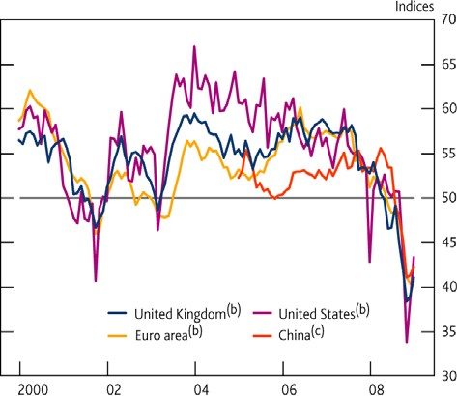

Chart 2 Oil prices

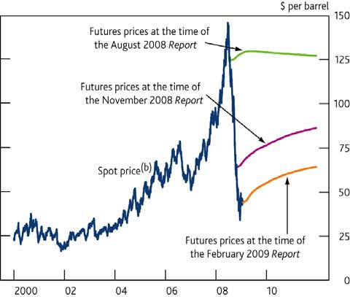

Chart 3 Consensus forecasts for world GDP growth in 2009

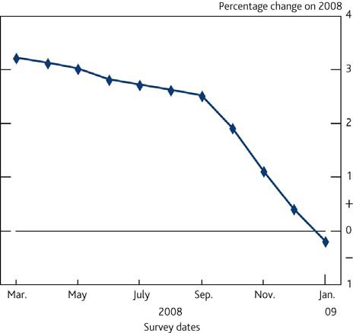

Chart 4 Nominal demand

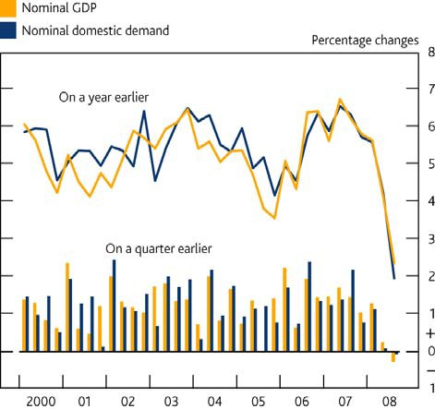

Chart 5 Broad money and credit

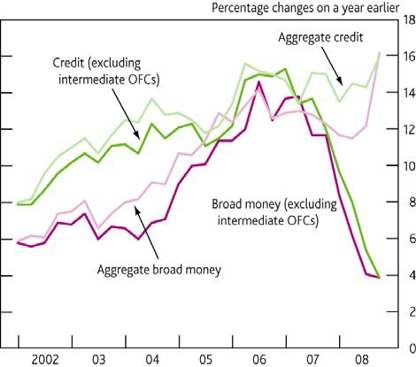

Chart 6 GDP projection based on market interest rate expectations

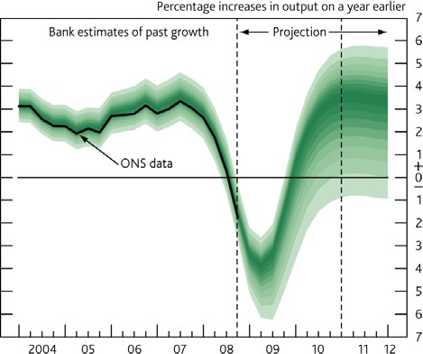

Chart 7 CPI inflation projection based on market interest rate expectations

